Other useful function that made us decide to use SHAP into our project was the summary plot. The summary plot combines feature importance with feature effects. Each point on the summary plot is a Shapley value for a feature and an instance. The position on the y-axis is determined by the feature and on the x-axis by the Shapley value. The color represents the value of the feature from low to high.

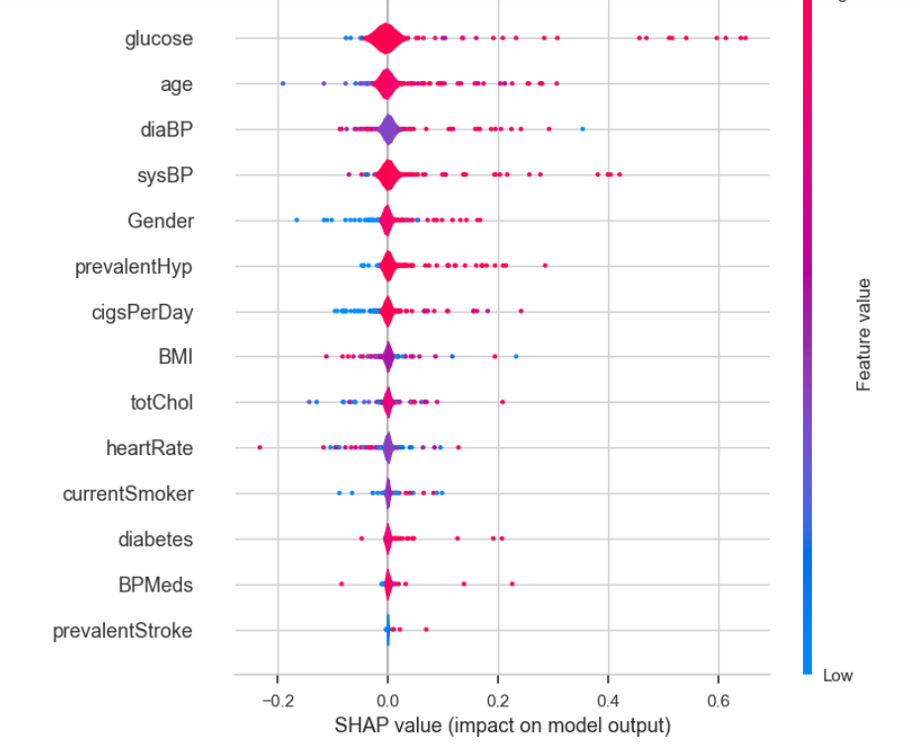

22 – Shap value impact on model output

On the bee swarm the features are also ordered by their effect on prediction, but we can also see how higher and lower values of the feature will affect the result.

All the little dots on the plot represent a single observation. The horizontal axis represents the SHAP value, while the color of the point shows us if that observation has a higher or a lower value, when compared to other observations. If you look at the feature “glucose ', you will see that it is mostly high with a positive SHAP value. It means higher the feature glucose is tending to a positive effect in the output. SHAP importance is measured at row level. It represents how a feature influences the prediction of a single row relative to the other features in that row and to the average outcome in the dataset.

Apart from machine learning interpretability and explanation, SHAP value can be used for:

**Model debugging**: by examining the SHAP values, we can identify any biases or outliers in the data that may be causing the model to make mistakes.

**Feature importance**: Identifying and removing low-impact features can create a more optimized model.

**Anchoring explanations:** We can use SHAP values to explain individual predictions by highlighting the essential features that caused that prediction. It can help users understand and trust a model's decisions.

**Model summaries:** It can provide a global summary of a model in the form of a SHAP value summary plot: It gives an overview of the most important features across the entire dataset.

**Detecting biases:** The SHAP value analysis helps identify if certain features disproportionately affect particular groups. It enables the detection and reduction of discrimination in the model.

**Fairness auditing:** It can be used to assess a model's fairness and ethical implications.

**Regulatory approval:** SHAP values can help gain regulatory approval by explaining the model's decisions.